Cost: FREE- supporting food unstable families
November 22nd 2019 at Collinsville Middle School

Food Mobile Market

When: 9:30-11:30 am
Where: 9649 Collinsville Rd, Collinsville, IL 62234
We are excited to announce that Collinsville Unit 10 is partnering with the St. Louis Area Foodbank to provide a Food Mobile Market for our Collinsville area families. This market is free of charge and though the available items rotate, often include dairy, meat, and fresh produce. We are hosting our first Food Mobile Market on Friday, November 22, 2019 at Collinsville Middle School, from 9:30-11:30 am. Mobile Markets will take place on a monthly basis and other host schools are being considered to reach more of our community.

This is a first come first served event with a capacity to serve 100+ families. If you are interested in receiving food from the mobile market, please arrive at Collinsville Middle School no earlier than 9:20 the day of the event. The event will be held in the west parking lot and is using a ‘drive through’ model. You will drive through the line, and we will have volunteers load the food items into your car. You will not need to leave your vehicle. Again, this is all provided free of charge.
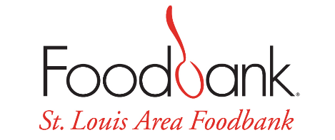
For more information please contact
our Collinsville Unit 10 social workers

Amy Buller (DIS) Lisa Melzer (Renfro)
abuller@cusd.kahoks.org lmelzer@cusd.kahoks.org

Megan White (CMS)
mwhite@cusd.kahoks.org

